**PANDAS ASSIGNMENT**

**Printing Rows and Columns**

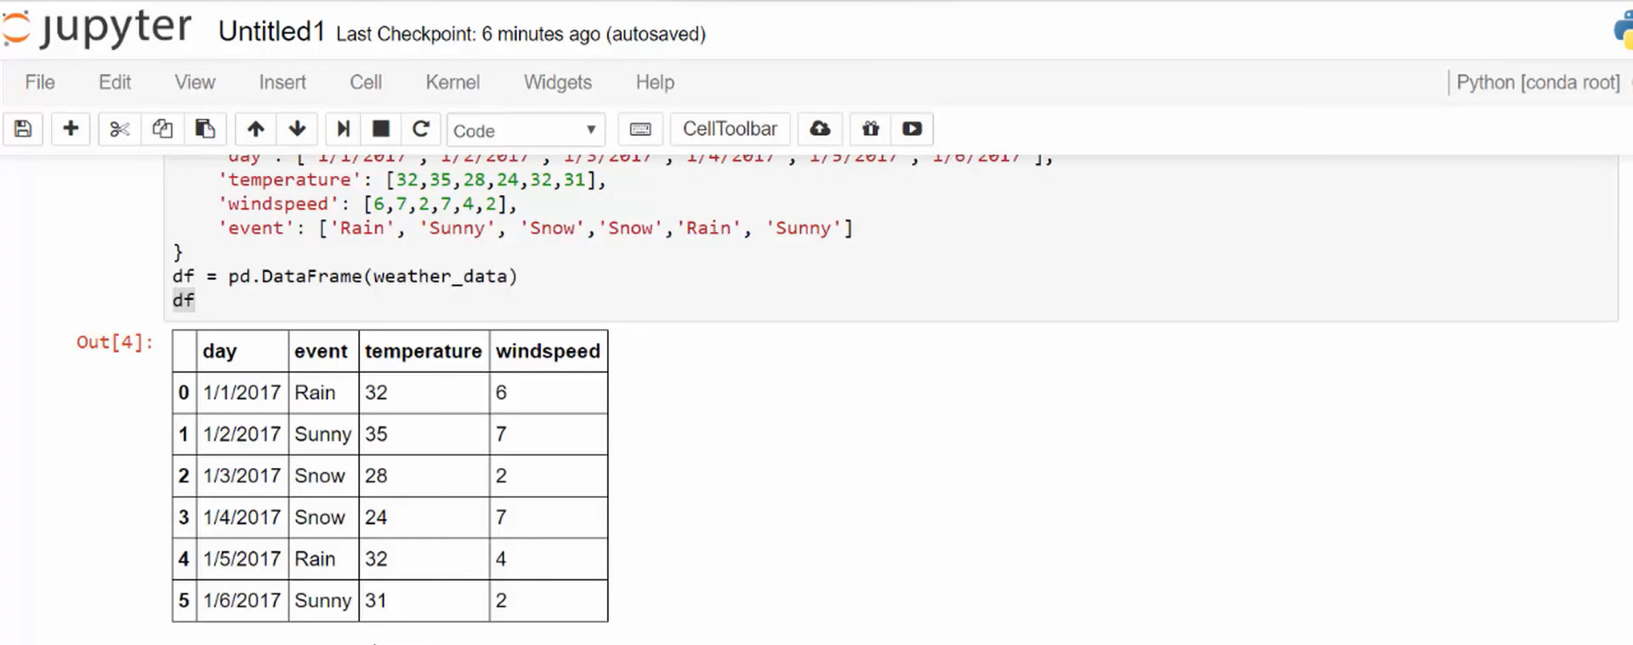

**Printing specific columns that I want**

